 | 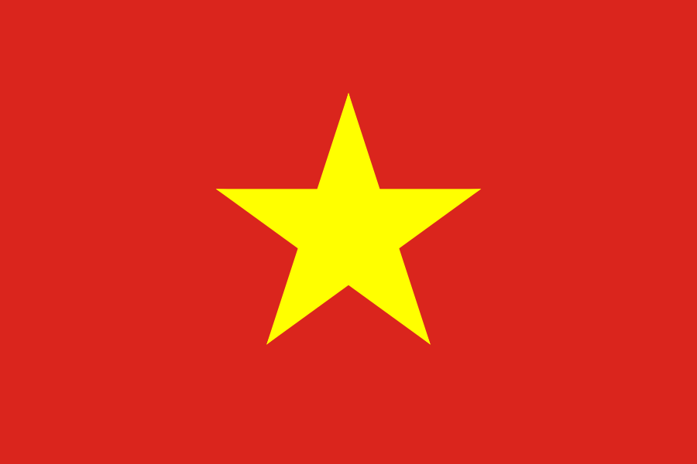


LIST OF BULGARIAN COMPANIES AND ORGANIZATIONS,
REGISTERED FOR THE BUSINESS DELEGATION TO VIETNAM, 22-30.11.2015

№ | Name of the company | Representative | Contact details | Main activities | Interest of cooperation
1. | Euroweg AG | 1. Galina Raicheva  2. Stefan Raitchev Ivanov | Sofia, 25 Krum Kyulyavkov Str. Floor 7, ap. 31  Phone: 0899621219  E-mail: galiaraicheva@yahoo.co.uk  Web: www.euroweg.bg  Silistra, 9 Hristo Smirnenski Str.  Phone: 0899180888  E-mail: raitchev@mekom.bg  Web: www.euroweg.bg | Trade with meat and ready meat products. | Trade, export of all kind of frozen meat to Vietnam. Find new partners. Trading with frozen meat and meat products. Like to import in Bulgaria fish products from Vietnam. To meet producers and traders of fish products. They have hotel and port in Silistra. To meet tourist agency for exchange of tourists
2. | Teletek Electronics JSC | Vassil Ivanov  Regional Sales Manager | 1000 Sofia, Bulgaria, 4 Dostoevski Str.  Phone: +359 882 570 126  Fax: +359 2 962 52 13  E-mail: vasil.ivanov@teletek-electronics.bg  Web: www.teletek-electronics.com | Manufacturing and export of full range intruder alarm systems and fire alarm systems. | Export and distribution of intruder alarm systems and fire alarm systems.
3. | NITI SHC | 1. Yuliyan Atanasov Lekov  Chairman of the Board of Directors of NITI SHC  2. Delyan Lalev Nachev  Managing Director of NITI SHC | Kazanlak, Bulgaria, 102, Rozova dolina Blvd.  Phone: 0889 20 33 33  Fax: 0431/6 50 59  E-mail: nitieadkazanlak@abv.bg  Web: www.nitibg.com | Develops and manufactures products for military use | Delivery of parachute targets for air defense and Air Force
4. | Baby food factory Ltd. | Nikolay Lubomirov Zehirev  CEO | 1505 Sofia, Bulgaria, 9, Kaimakchalan Str., app. 4  Phone: +359 888 807 808  Fax: +359 2 952 64 49  E-mail: manager@bpdniksi.com  Web: www.bpcniksi.com | Production and ditribution of baby foods and sterilized adult’s food | Building of baby food factory in Vietnam; finding distributors of baby foods
5. | HEP Technologies LTD /HEPT Ltd | Orlin Petkov  CEO | Bulgaria, Sofia 1517, Suhata Reka, Bl 17, vh B, ap 23 +359 889 801 768  office@hep-technologies.eu , orlinpetkov@hep-technologies.eu www.hep-technologies.eu | Special surfaces repair and maintenance treatment, obtained through proprietary technology, materials and components. Production and distribution of polymer solutions to protect and restore surface protection of concrete, masonry, plaster and metal erosion and damage due to water, chemical and abrasion, adverse weather, industrial, public waterproofing. Absorber technology that converts any porous surface to hydrophobic. Used to restore the paint flaking off the concrete to strengthen concrete surfaces and plasters, for protivohlazgavi coatings to protect concrete and metal surfaces from the effects of aggressive environments (chemicals, oils, fuels, acids and hydrooxides), weather, sweet and salty water. Aesthetic coatings for concrete and metals. Underwater restoration and protection works. | Partnership, creating a representation and distribution network for applying polymer solutions HEP Technologies  Protective coatings for reinforced concrete buildings and facilities of Nuclear, Water and Thermal power plants (NPPs, HPPs, TPP), large industrial enterprises, condensation towers, chimneys, spray pool, metal and concrete silos. Protective coatings for airports and airfields (Recovery of concrete stands for aircraft hangars, preventing spills of fuels, oils, waste water, hydraulic fluid, foreign objects impacting directly on flight safety, marking concrete and metal equipment and buildings on the airfield and appron stands for aircrafts. Restoring the concrete flakes (from 0.00 mm to no restrictions)). Protective coatings for sea, river, water, concrete structures (piers, columns, roads, ramps, buildings, retaining walls, water heater, water treatment plants, canals, various water facilities, port facilities). Protective coatings for roofs and parking stands of buildings. Protective coatings for concrete bridges and tunnels. Protective coatings for domestic use. Waterproofing.  Clients and partners: City authorities, airport authorities and aviation safety. Nuclear, Water and Thermal power plants operators authorities, the management of sea and river port and pier facilities. Owners of construction companies. Owners of large buildings, shopping centers.
6. | FILMAR INGENEERING & CONSULTING | 1. Georgi Filipov Filipov  Manager  2. Filip Georgiev Filipov  Project manager | 7 Gerganitsa str, ap4  1612 Sofia  + 359 885 222722  jorjfilipov@gmail.com  f_filmar@abv.bg | technological projects, consulting, engineering, equipment and supply lines for manufacturing enterprises of food industry | Project development, consulting, engineering, equipment supply
7. | VMZ | Tsonko Kirov Kirov  Deputy Managing Director | 4330 Sopot, Bulgaria, 1 Ivan Vazov Blvd  +359/3134 98-08  +359/2/9805504  kirov@vmz.bg  http://vmz.bg | machine-building, machinery construction | presentation of VMZ AD and joint activities
8. | TORSON COMMERCE LTD  APOTEX PHARMA LTD | Rosen NAUMOV  Managing Director | +359 876 93 66 33  apotexpharma@gmail.com | Vegetable oil producer and wholesaler  Pharmaceutical producer and wholesaler | Sales and distribution of vegetable oils. We are international wholesaler and distributor of vegetable oils. We are producing on sub-contracting basis different kind of vegetable oils. We are looking for a partner to establish a vegetable oil refinery and to refine the crude oil in Vietnam and to bottle it /own brand or client’s trademark/. We have the technology and the specialists.  Joint venture for pharmaceutical production. We are looking for partners to establish a pharmaceutical production according GMP standards. We are offering equipment, know-how, the technology and the specialists. Together with our partners from EU we are offering a range of medicines to be produced, to be registered and to be marketed all over the world, including several own trademarks.
9. | Velevi Pharma LTD | Georgi Velev Ivanov  Executive Manager | 1A Georgi Sofiiski str. , 1000 Sofia  0888/219949  02/ 491 38 04  veleva_ivelina@abv.bg  velevipharma.com | The company is specialized in production of food supplements. It has its own series of products which are natural of medicinal herbs, typical for our geographic range.  Velevi Pharma ООD is a licensed whole-sale merchant of medicines, medical products and cosmetics. The maintained articles are 15 000 in number. | Trading pharmaceutical and hospital products. Exports of food supplement Vietnam - our production.  Contacts with companies distributors of pharmaceutical and hospital products. Manufacturers of pharmaceutical and hospital products .
10 | Maple Leaf Poultry Ltd. | 1. Ivan Milev  CEO  2. Jordan Apostolov Apostolov  Manager | 14 Lulin Str.Dobrich  0887055867  i.k.milev@gmail.com  0899115501  Mlf.poultry@gmail.com | Breeder Duck Farm | Looking for a trade partner interested in Parent stock and Meat Duck day-olds and eggs.
11. | Podemcrane AD  www.podem.bg     | Georgi Ivanov  Regional Representative  Vietnam & ASEAN  Contacts:  georgi.ivanov@podem.bg  mobile: 0983621602  www.podem.bg | Headquarter:  1, Gen.Nikolov Str.  5300, Gabrovo  Bukgaria  Vietnamese office:  Floor 2, Building of five floors (Agrimeco), Km 10, National Highway 1A, Ngoc Hoi, Thanh Tri, Ha Noi, Vietnam | Design, production, delivery and installation of industrial and special cranes capacities up to 250t  Crane components: wire rope electric hoists, chain electric hoists, end carriages, gear motors, crane kits, spare parts. | Looking for contacts with local companies in lifting busines – wholesellers crane manufacturers, end users.  Interested in establishing long term busines relations for developing on local market.

