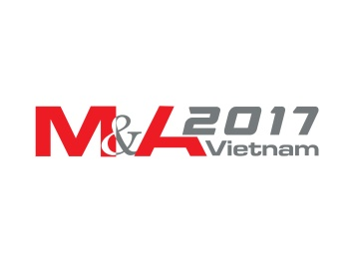

**REGISTRATION FORM**

**VIETNAM M&A FORUM 2017**

**August 10, 2017 – Ho Chi Minh City**

|  |  |  |  |
| --- | --- | --- | --- |
| **PACKAGES** | **FEE**  *(excluding VAT)* | **QUANTITY** | **TOTAL** |
| **Full package** *(Conference & Gala Dinner on August 10)* **(*)** | **USD 200** |  |  |
| **Master class on M&A strategy on August 11- 12** *(including a Conference Pass on August 10)* | **USD 750** |  |  |
| **Total Money Paid:** | | |  |
| ***In words:*** | | | |

*(*) Note: Participants that* ***register before July 10, 2017*** *or* ***register in groups of three*** *will be entitled for a 25 per cent discount, to* ***USD 150 per ticket.***

**Please fill in the registration form and mail to thu.nguyen**[**@avm.vn**](mailto:maf@avm.vn)**, or contact 0947 335 498 for further enquiries**

|  |  |  |  |
| --- | --- | --- | --- |
| *Participant information ( Please provide detailed information for networking activities)* | | | |
| **Participant 1** | | **Participant 2** | |
| Name :  Job title:  Department:  Tel:  Mobile:  Email: | | Name :  Job Title:  Department:  Tel:  Mobile:  Email: | |
| **Participant 3** | | **Participant 4** | |
| Name:  Job Title:  Department:  Tel:  Mobile:  Email: | | Name:  Job Title:  Department:  Tel:  Mobile:  Email: | |
| **Company Information** *(please provide full information to issue related invoices/receipts)* | | | |
| Company Name: | | | Address |
| Tax Code | Contact person/Mobile/Email : | | |
| Payment Details:   * VND Account: AVM Vietnam JSC, Account No: 001 100 400 4942 – Vietcombank, Hanoi, Vietnam * USD Account: AVM Vietnam JSC, Account No: 0011374010585 – Vietcombank Hanoi, Vietnam | | | |

VIETNAM M&A FORUM 2017

SEEKING A BIG PUSH

**MS: NHT**